**Java Web开发**

**实验五**

**作业报告**

|  |  |
| --- | --- |
| 学 院 | 计算机 |
| 所在系 班 级 | 2017软件工程系9班 |
| 学 号 姓 名 | 03170609 祝志豪 |
| 指 导 教 师 | 郭晓燕 |
| 完 成 时 间 | 2019年4月5日 |

# 实验题目

第四章课后练习3购物车，实现一个购物车应用程序，可以购物，显示购物数量并查看购物车内容。（此题模版test4E，提供给大家参考。）

# 分析与设计

根据题目要求，计划设计几个文件来完成实验，每个文件的名字、作用。如果是类，要求写出类的变量和方法

# 关键源码（部分）

**package** test5;

**import** java.io.Serializable;

**public** **class** Book {

String BookId;

String BookName;

**float** BookPrice;

**int** BookNumber;

String Bookimage;

**public** Book(String id,String name,String image,**int** num) {

**this**.BookId=id;

**this**.BookName=name;

**this**.Bookimage=image;

**this**.BookNumber=num;

}

**public** String getBookimage() {

**return** Bookimage;

}

**public** **void** setBookimage(String bookimage) {

Bookimage = bookimage;

}

**public** String getBookId() {

**return** BookId;

}

**public** **void** setBookId(String bookId) {

BookId = bookId;

}

**public** String getBookName() {

**return** BookName;

}

**public** **void** setBookName(String bookName) {

BookName = bookName;

}

**public** **float** getBookPrice() {

**return** BookPrice;

}

**public** **void** setBookPrice(**float** bookPrice) {

BookPrice = bookPrice;

}

**public** **int** getBookNumber() {

**return** BookNumber;

}

**public** **void** setBookNumber(**int** bookNumber) {

BookNumber = bookNumber;

}

}

<%@ page language=*"java"* import=*"java.util.*"* pageEncoding=*"UTF-8"*

%>

<%@ page import=*"test5.Book"* %>

<%

String path = request.getContextPath();

String basePath = request.getScheme()+"://"+request.getServerName()+":"+request.getServerPort()+path+"/";

%>

<!DOCTYPE HTML PUBLIC "-//W3C//DTD HTML 4.01 Transitional//EN">

<html>

<head>

<base href=*"*<%=basePath%>*"*>

<title>My JSP 'Shopping.jsp' starting page</title>

<meta http-equiv=*"pragma"* content=*"no-cache"*>

<meta http-equiv=*"cache-control"* content=*"no-cache"*>

<meta http-equiv=*"expires"* content=*"0"*>

<meta http-equiv=*"keywords"* content=*"keyword1,keyword2,keyword3"*>

<meta http-equiv=*"description"* content=*"This is my page"*>

<!--

<link rel="stylesheet" type="text/css" href="styles.css">

-->

</head>

<body>

<%String id=request.getParameter("id");

request.setCharacterEncoding("GB2312");

response.setContentType("text/html;charset=UTF-8");

**if**(session.getAttribute("booklist")==**null**)

{

Book[] books=**new** Book[4];

books[0]=**new** Book("0001","Java核心技术","D:/MyEclipse/img/10101.jpg",0);

books[1]=**new** Book("0002","Java经典实例","D:/MyEclipse/img/10102.jpg",0);

books[2]=**new** Book("0003","Java7","D:/MyEclipse/img/10103.jpg",0);

books[3]=**new** Book("0004","JSP&Servlet","D:/MyEclipse/img/10104.jpg",0);

request.getSession().setAttribute("booklist", books);

request.getSession().setAttribute("cout", 0);

}

%>

<img src=*"C:/Users/微笑的大猫/Pictures/购物车.jpg"* width=*'50px'* height=*'50px'*>

<a href=*'cart.view'*>已采购<%= request.getSession().getAttribute("cout")%>本书</a>

<br>

<%

Book[] booklist=(Book[])request.getSession().getAttribute("booklist");

**for**(Book book:booklist) {

%>

<tr>

<td> <img src=<%= book.getBookimage()%> width=*'100px'* height=*'100px'*> </td>

<td> <a href=*'shopping.view?id=*<%= book.getBookId()%>*'*>采购此书</a></td>

</tr>

<%

}

%>

</body>

</html>

package test5;

import java.io.IOException;

import javax.servlet.ServletException;

import javax.servlet.annotation.WebServlet;

import javax.servlet.http.HttpServlet;

import javax.servlet.http.HttpServletRequest;

import javax.servlet.http.HttpServletResponse;

import javax.servlet.http.HttpSession;

@WebServlet("/shopping.view")

public class ShoppingServlet extends HttpServlet {

private static final long serialVersionUID = 1L;

public ShoppingServlet() {

super();

}

protected void doGet(HttpServletRequest request, HttpServletResponse response) throws ServletException, IOException {

HttpSession session=request.getSession();

request.setCharacterEncoding("UTF-8");

String id=request.getParameter("id");

Book[] booklist=(Book[])session.getAttribute("booklist");

int cout=(Integer) session.getAttribute("cout");

for(int i=0;i<booklist.length;i++)

{

if(id.equals(booklist[i].getBookId()))

{

booklist[i].setBookNumber(booklist[i].getBookNumber()+1);

++cout;

}

}

request.getSession().setAttribute("booklist",booklist);

request.getSession().setAttribute("cout",cout);

request.getRequestDispatcher("Shopping.jsp").forward(request, response);

}

protected void doPost(HttpServletRequest request, HttpServletResponse response) throws ServletException, IOException {

doGet(request, response);

}

}

package test5;

import java.io.IOException;

import java.io.PrintWriter;

import javax.servlet.ServletException;

import javax.servlet.annotation.WebServlet;

import javax.servlet.http.HttpServlet;

import javax.servlet.http.HttpServletRequest;

import javax.servlet.http.HttpServletResponse;

import javax.servlet.http.HttpSession;

@WebServlet("/cart.view")

public class CartServlet extends HttpServlet {

public CartServlet() {

super();

}

public void destroy() {

super.destroy(); // Just puts "destroy" string in log

// Put your code here

}

public void doGet(HttpServletRequest request, HttpServletResponse response) throws ServletException, IOException {

this.doPost(request, response);

}

public void doPost(HttpServletRequest request, HttpServletResponse response) throws ServletException, IOException {

response.setContentType("text/html;charset=UTF-8");

HttpSession session=request.getSession();

PrintWriter out=response.getWriter();

int num=0;

out.println("<HTML><BODY><font size=1>");

Book[] booklist=(Book[])session.getAttribute("booklist");

for(int i=0;i<booklist.length;i++)

{

if(booklist[i].getBookNumber()>0)

{

out.println("商品："+booklist[i].getBookName()+"书本数："+booklist[i].getBookNumber()+"<br>");

out.println("<img src='"+booklist[i].Bookimage+"' width='100px' height='100px'>"+"<br>");

num=num+booklist[i].getBookNumber();

}

}

out.println("书本总数："+num+"<br>");

out.println("<a href='Shopping.jsp'>回到购物界面</a>"+"<br>");

out.println("</font></BODY></HTML>");

}

public void init() throws ServletException {

// Put your code here

}

}

# 运行效果图

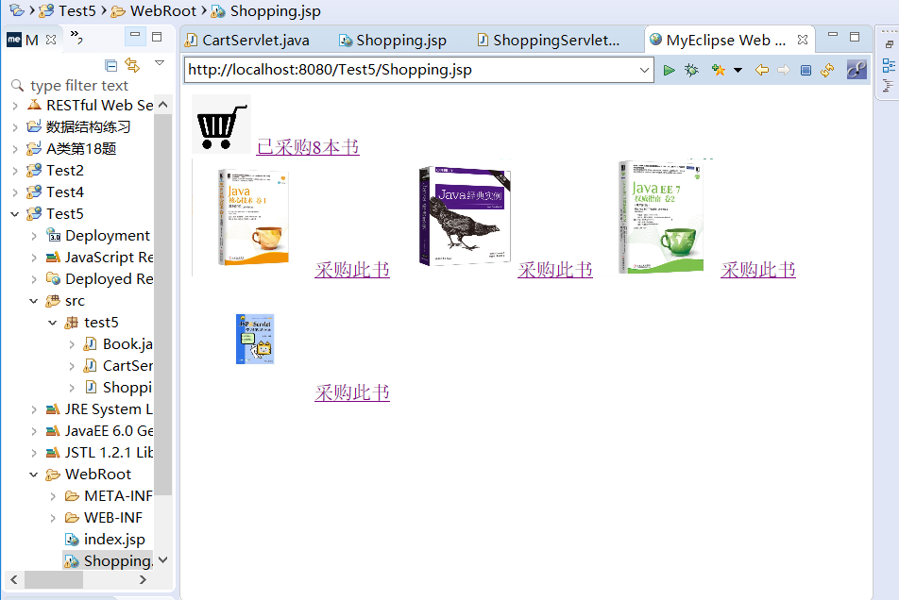

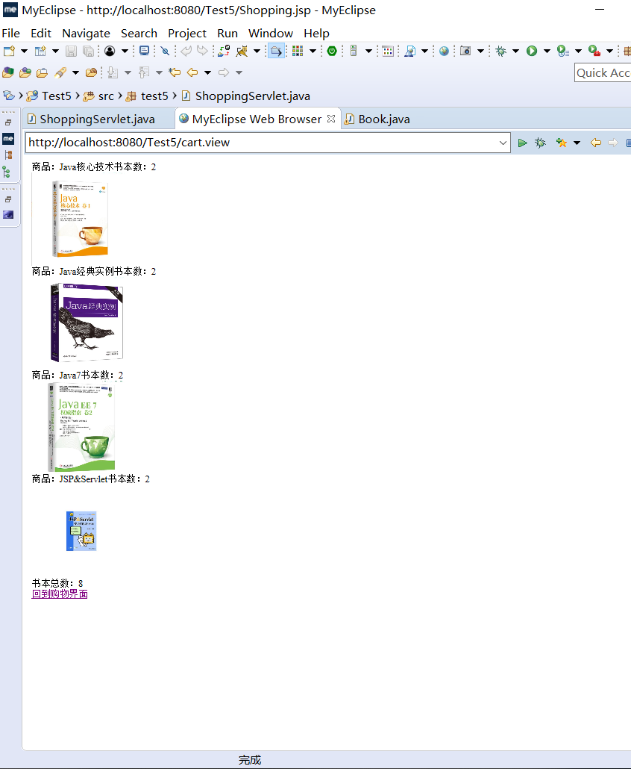

# 收获与问题